1st program
1) Create a directory
$mkdir Hadoop
2) Create a file in a Hadoop directory of file name hello.txt
$cd Hadoop/
$vi hello.txt
(Type the file content and Press Esc: wq)
3) Display the content of the File
$cat hello.txt
4) Create directory in HDFS
$hdfs dfs -mkdir /today
5) Copy the file from Hadoop to hdfs
$hdfs dfs -put hello.txt /today/data.txt
6) Copy the file within hdfs
$hdfs dfs -mkdir /input
$hdfs dfs -cp /today/data.txt /input/data.txt
$hdfs dfs -cat /input/data.txt
7) Copy the file from hdfs to Hadoop
$ hdfs dfs -get /input/data.txt
8) Delete the files
$hdfs dfs -rm /today/data.txt
9) Remove directory
$hdfs dfs -rmdir /today

2nd program
import org.apache.hadoop.conf.Configuration;
import org.apache.hadoop.fs.Path;
import org.apache.hadoop.io.IntWritable;
import org.apache.hadoop.io.Text;
import org.apache.hadoop.mapreduce.Job;
import org.apache.hadoop.mapreduce.Mapper;
import org.apache.hadoop.mapreduce.Reducer;
import org.apache.hadoop.mapreduce.lib.input.FileInputFormat;
import org.apache.hadoop.mapreduce.lib.output.FileOutputFormat;
import java.io.IOException;
import java.util.StringTokenizer;

public class WordCount {

public static class TokenizerMapper
extends Mapper<Object, Text, Text, IntWritable> {

private final static IntWritable one = new IntWritable(1);
private Text word = new Text();

public void map(Object key, Text value, Context context)
throws IOException, InterruptedException {

StringTokenizer itr = new StringTokenizer(value.toString());
while (itr.hasMoreTokens()) {
word.set(itr.nextToken());
context.write(word, one);
}
}
}

public static class IntSumReducer
extends Reducer<Text, IntWritable, Text, IntWritable> {

public void reduce(Text key, Iterable<IntWritable> values,
Context context)
throws IOException, InterruptedException {

int sum = 0;
for (IntWritable val : values) {
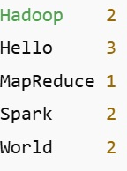
sum += val.get();
}
context.write(key, new IntWritable(sum));
}
}
public static void main(String[] args) throws Exception {

Configuration conf = new Configuration();
Job job = Job.getInstance(conf, "word count");

job.setJarByClass(WordCount.class);
job.setMapperClass(TokenizerMapper.class);
job.setCombinerClass(IntSumReducer.class);
job.setReducerClass(IntSumReducer.class);
job.setOutputKeyClass(Text.class);
job.setOutputValueClass(IntWritable.class);
FileInputFormat.addInputPath(job, new Path(args[0]));
FileOutputFormat.setOutputPath(job, new Path(args[1]));
System.exit(job.waitForCompletion(true) ? 0 : 1);
}
}
Sample.txt
hello Hadoop
hello big data
Execution steps
- gedit WordCount.java
- javac -classpath `hadoop classpath` -d . WordCount.java
- jar cf wc.jar WordCount*.class
- hdfs dfs -mkdir -p /user/cloudera/input
- gedit sample.txt
- hdfs dfs -put sample.txt /user/cloudera/input/
- hdfs dfs -ls /user/cloudera/input
- hadoop jar wc.jar WordCount /user/cloudera/input /user/cloudera/output
If error hdfs dfs -rm -r /user/cloudera/output then run again
- hdfs dfs -cat /user/cloudera/output/part-r-00000

3rd program
def mapper(A, B):
return[((i,j), A[i][k] * B[k][j])
for i in range(len(A))
for j in range(len(B[0]))
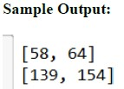
for k in range(len(B))]

def reducer(pairs):
result={}
for keys, val in pairs:
result[keys]=result.get(keys, 0)+val
return result
def to_matrix(res, r , c):
M=[[0]*c for _ in range(r)]
for [i,j], v in res.items():
M[i][j]=v
return M

A=[[1,2,3], [4,5,6]]
B=[[7,8], [9,10], [11, 12]]

res=reducer(mapper(A, B))
print(to_matrix(res, len(A), len(B[0])))
4th Program
db.createCollection("students")
db.students.insertMany([
{ "_id": 1, "name": "Alice", "age": 22, "marks": 85 },
{ "_id": 2, "name": "Bob", "age": 21, "marks": 78 },
{ "_id": 3, "name": "Charlie", "age": 23, "marks": 92 },
{ "_id": 4, "name": "David", "age": 20, "marks": 88 },
{ "_id": 5, "name": "Eve", "age": 22, "marks": 76 }
])
db.students.countDocuments({ age: { $gt: 20 } })
db.students.find().sort({ marks: -1 })
db.students.find().sort({ marks: -1 }).limit(3)
db.students.find().sort({ marks: -1 }).skip(2)
db.students.aggregate([
{ $group: { _id: "$age", avgMarks: { $avg: "$marks" } } }
])
onecompiler.com/mongodb/44asrg4ft

6th program
- Start Hadoop Service
start-all.sh (in terminal)
- Verify
jps
- Start Hive shell
hive
You will enter:
hive>
- Create database
CREATE DATABASE employee_db;
Use the database:
USE employee_db;
- Alter database
ALTER DATABASE employee_db
SET DBPROPERTIES ('Owner'='Admin');
- Create Table
CREATE TABLE employees (
emp_id INT,
name STRING,
age INT,
dept_id INT,
salary FLOAT
)
ROW FORMAT DELIMITED
FIELDS TERMINATED BY ','
STORED AS TEXTFILE;
- Load data into table (first exit hive temporarily):
exit;
create input file:
gedit employees.txt
Paste:
101,John,30,1,50000
102,Sam,28,2,60000
103,Anna,32,1,75000
104,David,29,3,62000
105,Lily,27,2,58000
Upload to HDFS:
hdfs dfs -put employees.txt /user/cloudera/
Start Hive again:
hive
USE employee_db;
Local data:
LOAD DATA INPATH '/user/cloudera/employees.txt'
INTO TABLE employees;
- Display table data
SELECT * FROM employees;
- Alter table
ALTER TABLE employees ADD COLUMNS (email STRING);
- Rename table
ALTER TABLE employees RENAME TO employees_new;
- Create view
CREATE VIEW high_salary_employees AS
SELECT emp_id, name, salary
FROM employees_new
WHERE salary > 50000;
- Alter view
ALTER VIEW high_salary_employees AS
SELECT emp_id, name, age, salary
FROM employees_new
WHERE salary > 60000;
- Drop View
DROP VIEW high_salary_employees;
- Create Function (UDF)
ADD JAR /user/cloudera/custom_udf.jar;
CREATE FUNCTION to_upper AS 'com.example.hiveudf.ToUpperUDF';
Use function:
SELECT to_upper(name) FROM employees_new;
Drop function:
DROP FUNCTION to_upper;
- Create Index
CREATE INDEX emp_dept_idx
ON TABLE employees_new (dept_id)
AS 'org.apache.hadoop.hive.ql.index.compact.CompactIndexHandler'
WITH DEFERRED REBUILD;
Rebuild Index:
ALTER INDEX emp_dept_idx ON employees_new REBUILD;
Drop index:
DROP INDEX emp_dept_idx ON employees_new;
- Drop table
DROP TABLE employees_new;
- Drop database
DROP DATABASE employee_db CASCADE;

10th Program
def mapper(line):
date, condition = line.strip().split(',', 1) # ✅ FIX
return (date, condition)

# Reducer
def reducer(date, conditions):
count = {}
for c in conditions:
count[c] = count.get(c, 0) + 1
return (date, max(count, key=count.get))

# Driver
def main(file):
lines = open(file).readlines()

mapped = []
for line in lines:
if line.strip():
mapped.append(mapper(line))

grouped = {}
for date, cond in mapped:
grouped.setdefault(date, []).append(cond)

for date, conds in grouped.items():
d, result = reducer(date, conds)
print(f"Weather on {d}: {result}")
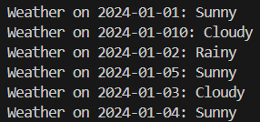
# Run
if __name__ == "__main__":
main("weather.txt")

weather.txt
2024-01-01,Sunny
2024-01-010,Cloudy
2024-01-02,Rainy
2024-01-05,Sunny
2024-01-03,Cloudy
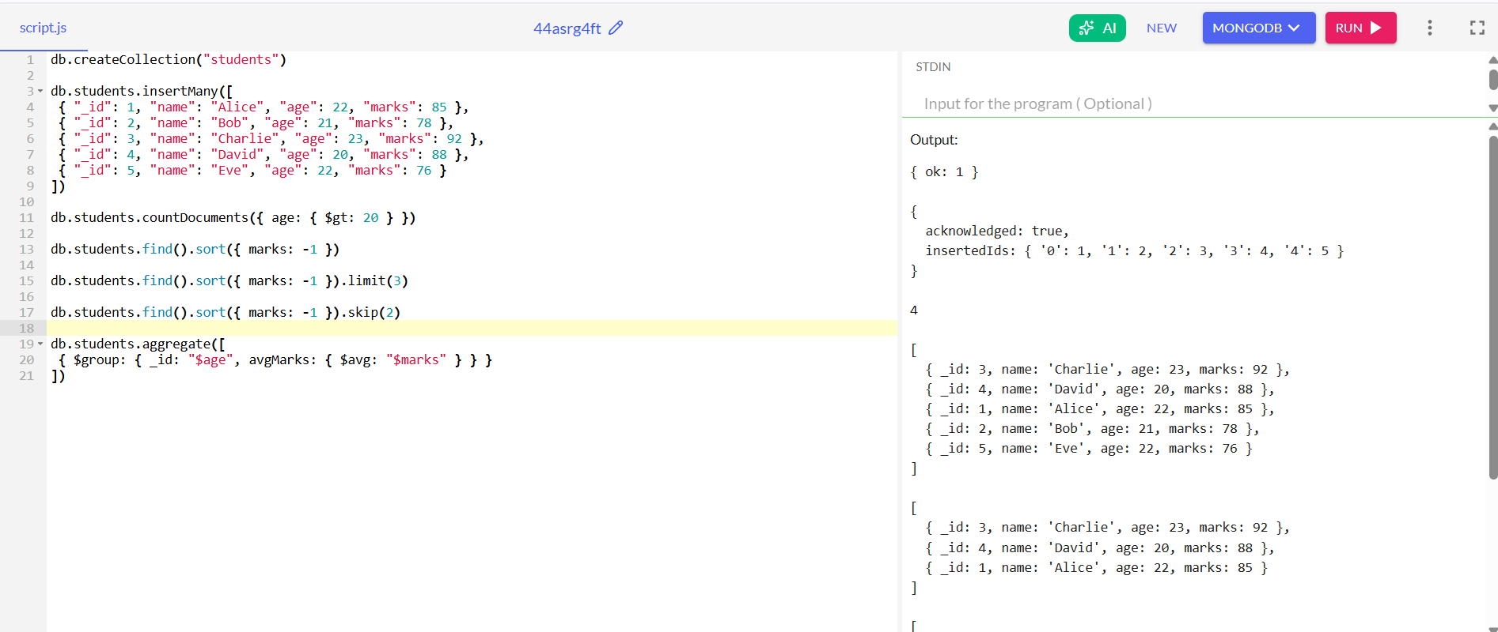
2024-01-04,Sunny
4th o/p

